# 1)Brief Report on any open source project:-

# Terra project:-

Terra is an open-source blockchain payment platform for an algorithmic stablecoin, which are cryptocurrencies that automatically track the price of currencies or other assets. The Terra blockchain enables users to instantly spend, save, trade, or exchange Terra stablecoins.

The Terra protocol creates stablecoins designed to consistently track the price of a fiat currency (a government-backed currency such as the U.S. dollar or euro). It consists of two cryptocurrency tokens—Terra and Luna.

Features of Terra:-

* Terra is an open-source blockchain protocol that underpins algorithmic stablecoins and a network of financial applications.
* Terra is one of the two main cryptocurrency tokens under this protocol, the other one being Luna.
* Terra stablecoins track the price of fiat currencies like the U.S. dollar and euro, while Luna is used for blockchain governance.
* The Terra protocol maintains the price of the Terra stablecoin by ensuring that the supply and demand for it are always balanced. This is achieved by using Luna as the variable counterweight to the Terra stablecoin.

Community Meeting Info:-

## Community

Terraform is an open source project with a growing community. There are active, dedicated users willing to help you through various mediums.

Project Organisation:-

**Terra** is a [blockchain](https://en.wikipedia.org/wiki/Blockchain" \o "Blockchain) protocol and payment platform used for [algorithmic stablecoins](https://en.wikipedia.org/wiki/Algorithmic_stablecoin). The project was created in 2018 by **Terraform Labs**, a startup co-founded by [Do Kwon](https://en.wikipedia.org/wiki/Do_Kwon) and Daniel Shin. It is most known for its Terra [stablecoin](https://en.wikipedia.org/wiki/Stablecoin" \o "Stablecoin) and the associated Luna reserve asset [cryptocurrency](https://en.wikipedia.org/wiki/Cryptocurrency" \o "Cryptocurrency).

In May 2022, the Terra blockchain was temporarily halted after the collapse of the stablecoin TerraUSD (UST) and Luna,[[1]](https://en.wikipedia.org/wiki/Terra_(blockchain)" \l "cite_note-1) in an event that wiped out almost $45 billion in [market capitalisation](https://en.wikipedia.org/wiki/Market_capitalisation) within a week.

# 2) Open Source Understanding Chart:-

Open source refers to open source software (OSS). Open source software is code that is designed to be publicly accessible- anyone can see, modify, and distribute the code as they see. The software is then released under an open source license, so anyone can view or modify the source code. Many open source projects are hosted on GitHub, where you can access repositories or get involved in community projects.

ADVANTAGE OF OPEN SOURCE OVER PROPRIETARY:-­

There are lots of reasons why people choose open source over proprietary software, but the most common ones are:

* Peer review: The source code is freely accessible and the open source community is very active, open source code is actively checked and improved upon by peer programmers.
* Transparency: Open source allows you to check and track that exactly what kinds of data are moving where, or what kinds of changes have happened in the code for yourself, without having to rely on vendor promises.
* Reliability: Proprietary code relies on the single author or company controlling that code to keep it updated, patched, and working. Open source code outlives its original authors because it is constantly updated through active open source communities.
* Flexibility: Because of its emphasis on modification, you can use open source to address problems that are unique to your business or community. You aren’t locked in to using the code in any one specific way.
* Lower cost: Open source platforms provide free access for everyone. Anyone can ask solution for any type of organization problem and can get response of that without paying anything.
* Open collaboration: The existence of active open source communities means that you can find help, resources, and perspectives that reach beyond one interest group or one company.

# 3) SODA FOUNDATION Chart:-

It is an Open source project under Linux Foundation that aims to foster an ecosystem of open source data management and storage software for data autonomy. SODA Foundation offers a neutral forum for cross-projects collaboration and integration and provides end users quality end-to-end solutions.

Ambitions;-

An ecosystem for data and storage management with cross project and community collaboration to offer open platforms, frameworks and standards to build highly competative and compliant products & solutions.

Organisational structure:-

SODA Foundation is a project of the Linux Foundation.

SODA Foundation is overseen by the [Governing Board](https://www.sodafoundation.io/the-foundation/governing-board/) supported by 3 main committees.

**SODA Governance Structure:-**

[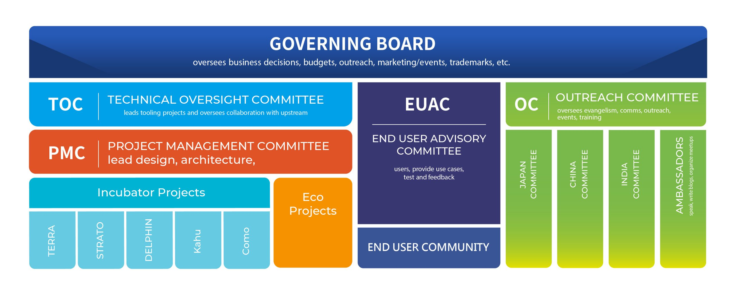](https://www.sodafoundation.io/wp-content/uploads/2022/05/2022_GOVERNANCE3840-scaled.jpg)

* PROJECTS:SODA Foundation has been working on multiple projects. Few of the main projects of SODA are menoned below:-
* Delfin: It is SODA Infrastructure Manager project which provides unified, intelligent and scalable resource management, alert and performance monitoring. It will provide a scalable framework where more and more backends as well as client exporters can be added.
* Strato: This project provides a cloud vendor agnostic data management for hybrid cloud, intercloud or intracloud. It provides an s3-compable interface. It can be hosted on prem or cloud nave. This is one of the SODA Core Projects and is maintained by SODA directly. STRATO has been renamed from “SODA Mul Cloud Project”.
* Kahu: Kahu is part of SODA Container Data Foundation Management(CDM). Kahu provides seamless backup/restore for Kubernetes resources and data.